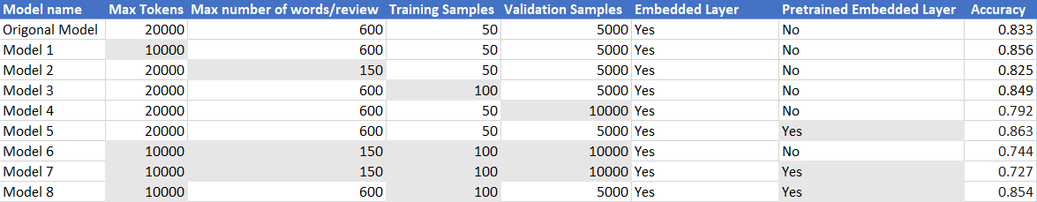

One of the most surprising outcomes from the report is the impact validation samples has on the model’s accuracy. Specifically, it appears that as you increase the validation samples it decreases the accuracy of the model. This could be due to larger number of validation samples causing the model to overfit.
Another interesting outcome from the report is how decreasing the max number of words per review appears to have a negative impact on the accuracy of the model. Likely due to the model loosing out on important context in those words in those reviews.
The most dramatic improvement was caused by using a Pretrained Embedded Layer with all other variables being the same as the original model giving a .03 increase in accuracy. This shows how impactful the extra context that pretraining gives a model is.
For non-pretrained models it appears that decreasing max tokens, and increasing training sample sizes have a positive impact on the accuracy the model. Decreasing max tokens likely cuts down on the effect less used words have on the model which is likely good due to the lack of context the model has for those words. And increasing training samples likely give the model more data to work with giving the model more context for the words.
Another notable finding from the report is that adding all of the changes that had positive impacts to one model creates a model that is less accurate then just pre training the embedded layer of the original model. That is likely due to the fact that the ideal hyperparameters for a pretrained model are different then for a non-pretrained model. And are more closely related to the hyperparameters of the original model.

